# **Lab 3**

Author: Qadeer Hussain

Student ID: C00270632

Table of Contents

**Lab 3** 1

**Objective** 2

**Kubernetes Basic Module** 2

**Using Minikube to Create a Cluster** 3

**Hello Minikube Tutorial** 3

**Create a Minikube cluster** 3

**Open the Dashboard** 3

**Create a deployment** 4

**Create a Service** 6

**Enable addons** 7

**Clean up** 8

**Using kubectl to Create a Deployment** 9

**Deploying your first app on Kubernetes** 9

**Viewing Pods and Nodes** 10

**Troubleshooting with kubectl** 10

**Using a Service to Expose Your App** 12

**Services and Labels** 12

Running Multiple Instances of Your App 15

Scaling an application 15

## **Objective**

In this lab for Kubernetes Basics the objective is to

* Deploy a containerized application on a cluster.
* Scale the deployment.
* Update the containerized application with a new software version.
* Debug the containerized application

## **Kubernetes Basic Module**

### **Using Minikube to Create a Cluster**

Begin Hello Minikube tutorial

<https://kubernetes.io/docs/tutorials/hello-minikube/>

Install Kubectl

Then continue on with running Minikube start

**Note: Windows CMD doesn’t support export or $, use kubectl get pods to copy the pod name manually instead.**

## **Hello Minikube Tutorial**

### **Create a Minikube cluster**

### **Open the Dashboard**

### **Create a deployment**



### **Create a Service**



### **Enable addons**

### **Clean up**

## **Using kubectl to Create a Deployment**

### **Deploying your first app on Kubernetes**

#### **kubectl basics**

#### **Deploy an app**



#### **View the app**

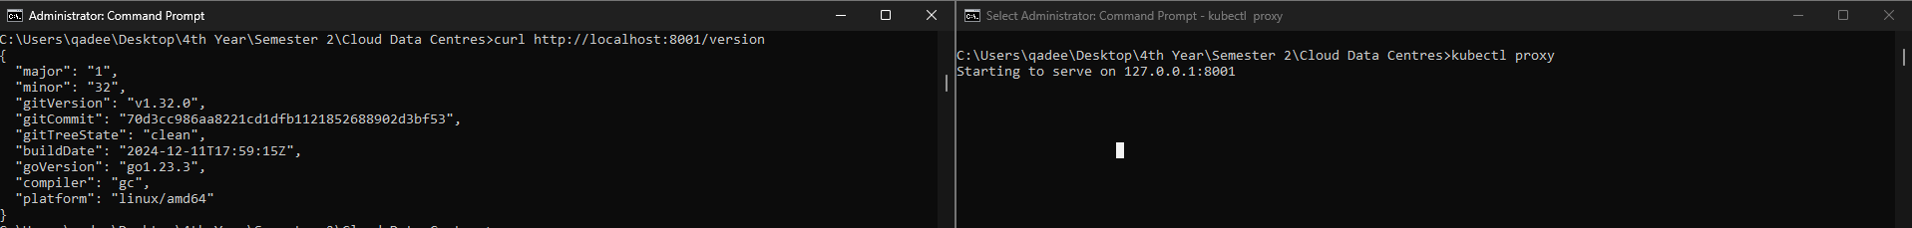

## **Viewing Pods and Nodes**

### **Troubleshooting with kubectl**

#### **Check application configuration**

#### **Show the app in the terminal**

#### **Executing commands on the container**

## **Using a Service to Expose Your App**

### **Services and Labels**

#### **Step 1: Creating a new Service**



#### **Step 2: Using labels**

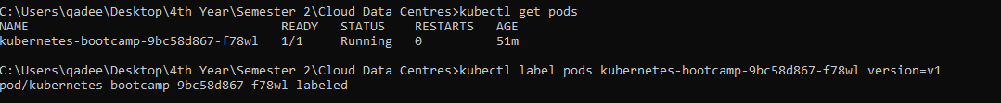

#### **Step 3: Deleting a service**

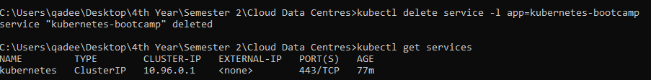

## **Running Multiple Instances of Your App**

### **Scaling an application**

#### **Scaling a Deployment**

#### **Load Balancing**

#### **Scale Down**

## **Performing a Rolling Update**

### **Rolling updates overview**

#### **Update the version of the app**

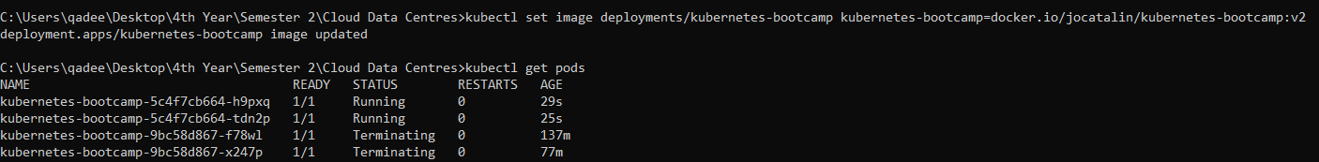

#### **Verify an update**

#### **Roll back an update**

